**Java Assignment 10**

**Name: B.Satlas Rohit**

**Regno : 2024503305**

**Code 1:**

**import javax.swing.*;  
import java.awt.*;  
import java.awt.event.*;  
public class Score extends JFrame implements ActionListener {  
 JLabel q1Label, q2Label, q3Label, nameLabel;  
 JRadioButton q1a1, q1a2, q1a3, q1a4;  
 JCheckBox q2a1, q2a2, q2a3, q2a4;  
 JTextField nameField;  
 JTextArea commentArea;  
 JButton submitButton, clearButton;  
 ButtonGroup q1Group;  
 int score = 0;  
 Score() {  
 setTitle("Interactive Quiz");  
 setLayout(new GridLayout(10, 1));  
 setSize(400, 600);  
 setDefaultCloseOperation(JFrame.*EXIT_ON_CLOSE*);  
 nameLabel = new JLabel("Enter your name:");  
 nameField = new JTextField(15);  
 add(nameLabel);  
 add(nameField);  
 q1Label = new JLabel("Q1. What is the capital of India?");  
 q1a1 = new JRadioButton("New Delhi");  
 q1a2 = new JRadioButton("Mumbai");  
 q1a3 = new JRadioButton("Kolkata");  
 q1a4 = new JRadioButton("Chennai");  
 q1Group = new ButtonGroup();  
 q1Group.add(q1a1);  
 q1Group.add(q1a2);  
 q1Group.add(q1a3);  
 q1Group.add(q1a4);  
 add(q1Label);  
 add(q1a1); add(q1a2); add(q1a3); add(q1a4);  
 q2Label = new JLabel("Q2. Select the programming languages:");  
 q2a1 = new JCheckBox("Java");  
 q2a2 = new JCheckBox("Python");  
 q2a3 = new JCheckBox("HTML");  
 q2a4 = new JCheckBox("C++");  
 add(q2Label);  
 add(q2a1); add(q2a2); add(q2a3); add(q2a4);  
 q3Label = new JLabel("Q3. Who developed Java?");  
 commentArea = new JTextArea(2, 15);  
 add(q3Label);  
 add(commentArea);  
 submitButton = new JButton("Submit");  
 clearButton = new JButton("Clear");  
 add(submitButton);  
 add(clearButton);  
 submitButton.addActionListener(this);  
 clearButton.addActionListener(this);  
 setVisible(true);  
 }  
 @Override  
 public void actionPerformed(ActionEvent e) {  
 if (e.getSource() == submitButton) {  
 calculateScore();  
 } else if (e.getSource() == clearButton) {  
 clearAll();  
 }  
 }  
 void calculateScore() {  
 score = 0;  
 if (q1a1.isSelected()) score += 1;  
 if (q2a1.isSelected()) score += 1;  
 if (q2a2.isSelected()) score += 1;  
 if (q2a4.isSelected()) score += 1;  
 if (commentArea.getText().trim().equalsIgnoreCase("James Gosling")) score += 1;  
 JOptionPane.*showMessageDialog*(this,  
 "Name: " + nameField.getText() +  
 "\nYour Total Score: " + score +  
 "\n\nCorrect Answers:\n1. New Delhi\n2. Java, Python, C++\n3. James Gosling");  
 }  
 void clearAll() {  
 nameField.setText("");  
 q1Group.clearSelection();  
 q2a1.setSelected(false);  
 q2a2.setSelected(false);  
 q2a3.setSelected(false);  
 q2a4.setSelected(false);  
 commentArea.setText("");  
 }  
 public static void main(String[] args) {  
 new Score();  
 }  
}**

**Output:**

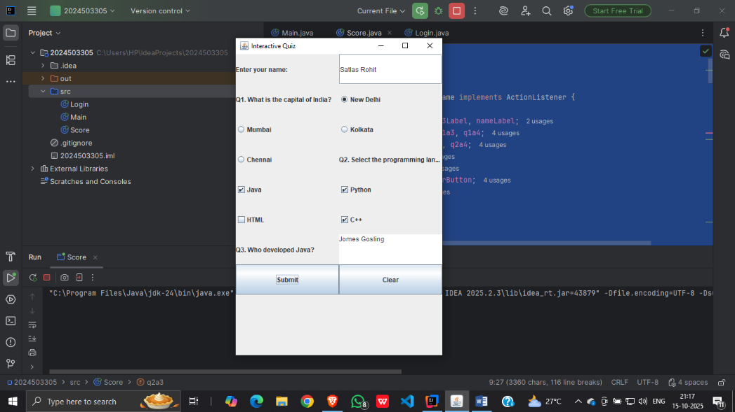

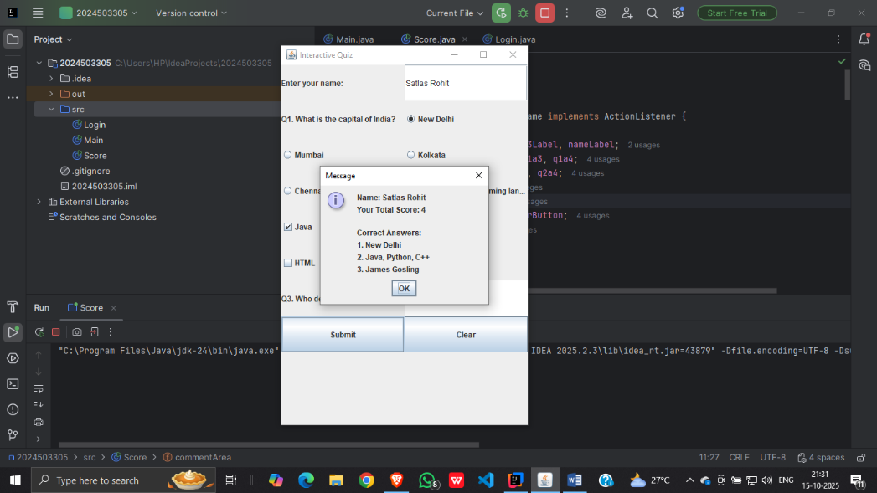

**Code 2:**

**import javax.swing.*;  
import java.awt.*;  
import java.awt.event.*;  
public class Shopping extends JFrame implements ActionListener {  
 JCheckBox item1, item2, item3, item4;  
 JButton totalButton, clearButton;  
 JTextArea displayArea;  
 int total = 0;  
 Shopping() {  
 setTitle("Shopping Cart");  
 setSize(400, 400);  
 setLayout(new FlowLayout());  
 setDefaultCloseOperation(JFrame.*EXIT_ON_CLOSE*);  
 item1 = new JCheckBox("Laptop - ₹50000");  
 item2 = new JCheckBox("Phone - ₹20000");  
 item3 = new JCheckBox("Headphones - ₹2000");  
 item4 = new JCheckBox("Smartwatch - ₹3000");  
 totalButton = new JButton("Calculate Total");  
 clearButton = new JButton("Clear Cart");  
 displayArea = new JTextArea(8, 25);  
 displayArea.setEditable(false);  
 add(new JLabel("Select the items you want to buy:"));  
 add(item1); add(item2); add(item3); add(item4);  
 add(totalButton); add(clearButton);  
 add(new JScrollPane(displayArea));  
 totalButton.addActionListener(this);  
 clearButton.addActionListener(this);  
 setVisible(true);  
 }  
 public void actionPerformed(ActionEvent e) {  
 if (e.getSource() == totalButton) {  
 total = 0;  
 StringBuilder sb = new StringBuilder("Items in your cart:\n");  
  
 if (item1.isSelected()) { sb.append("Laptop - ₹50000\n"); total += 50000; }  
 if (item2.isSelected()) { sb.append("Phone - ₹20000\n"); total += 20000; }  
 if (item3.isSelected()) { sb.append("Headphones - ₹2000\n"); total += 2000; }  
 if (item4.isSelected()) { sb.append("Smartwatch - ₹3000\n"); total += 3000; }  
 sb.append("\nTotal Amount: ₹").append(total);  
 displayArea.setText(sb.toString());  
 } else if (e.getSource() == clearButton) {  
 item1.setSelected(false);  
 item2.setSelected(false);  
 item3.setSelected(false);  
 item4.setSelected(false);  
 displayArea.setText("");  
 }  
 }  
 public static void main(String[] args) {  
 System.*out*.println("Name:B.Satlas Rohit\nRegno:2024503305");  
 new Shopping();  
 }  
}**

**Output:**

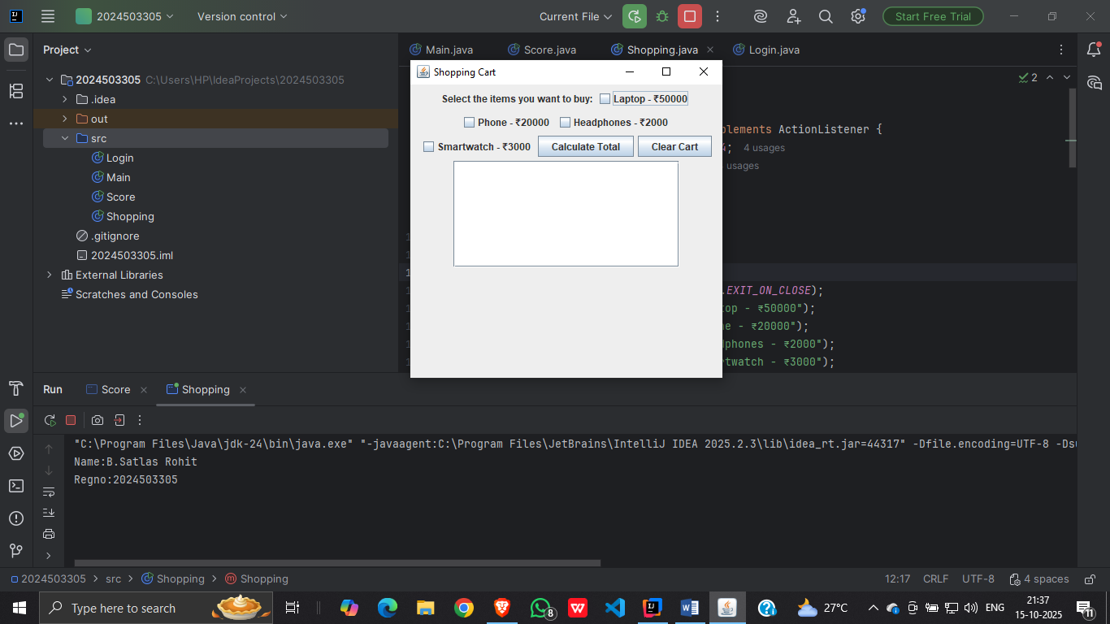

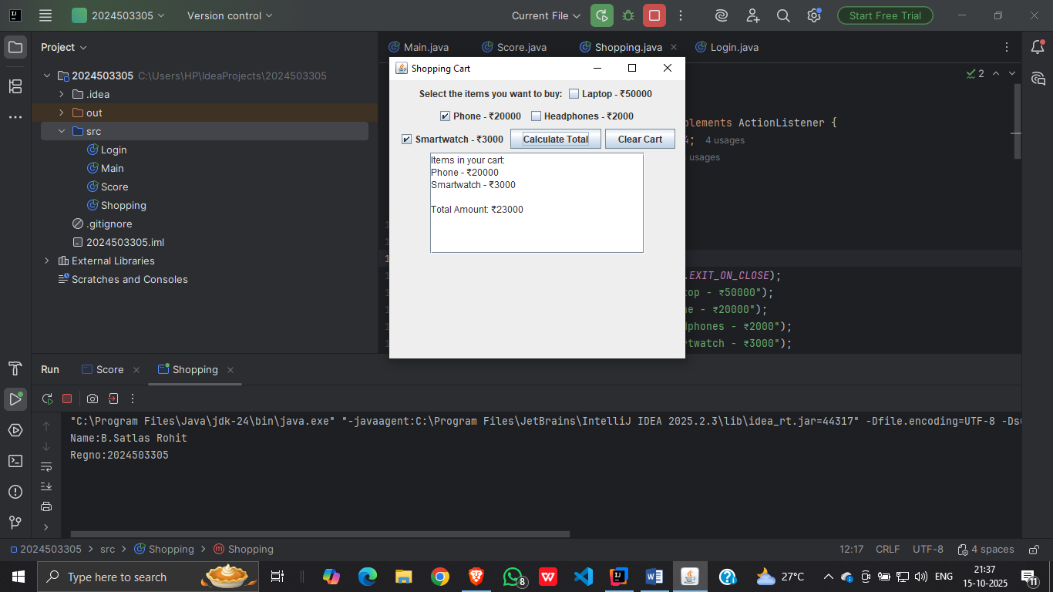

**Code 3:**

**import javax.swing.*;**

**import java.awt.*;**

**import java.awt.event.*;**

**class EmptyFieldException extends Exception {**

**public EmptyFieldException(String msg) { super(msg); }**

**}**

**class InvalidEmailException extends Exception {**

**public InvalidEmailException(String msg) { super(msg); }**

**}**

**class PasswordMismatchException extends Exception {**

**public PasswordMismatchException(String msg) { super(msg); }**

**}**

**class WeakPasswordException extends Exception {**

**public WeakPasswordException(String msg) { super(msg); }**

**}**

**public class GoogleAccountForm extends JFrame implements ActionListener {**

**JLabel nameLabel, emailLabel, passLabel, confirmLabel;**

**JTextField nameField, emailField;**

**JPasswordField passField, confirmField;**

**JButton submitButton, clearButton;**

**GoogleAccountForm() {**

**setTitle("Google Account Creation");**

**setLayout(new GridLayout(5, 2, 10, 10));**

**setSize(400, 250);**

**setDefaultCloseOperation(JFrame.EXIT_ON_CLOSE);**

**nameLabel = new JLabel("Name:");**

**emailLabel = new JLabel("Email:");**

**passLabel = new JLabel("Password:");**

**confirmLabel = new JLabel("Confirm Password:");**

**nameField = new JTextField(15);**

**emailField = new JTextField(15);**

**passField = new JPasswordField(15);**

**confirmField = new JPasswordField(15);**

**submitButton = new JButton("Create Account");**

**clearButton = new JButton("Clear");**

**add(nameLabel); add(nameField);**

**add(emailLabel); add(emailField);**

**add(passLabel); add(passField);**

**add(confirmLabel); add(confirmField);**

**add(submitButton); add(clearButton);**

**submitButton.addActionListener(this);**

**clearButton.addActionListener(this);**

**setVisible(true);**

**}**

**public void actionPerformed(ActionEvent e) {**

**if (e.getSource() == submitButton) {**

**try {**

**validateInputs();**

**JOptionPane.showMessageDialog(this, "Account Created Successfully!");**

**} catch (Exception ex) {**

**JOptionPane.showMessageDialog(this, ex.getMessage(), "Error", JOptionPane.ERROR_MESSAGE);**

**}**

**} else if (e.getSource() == clearButton) {**

**nameField.setText("");**

**emailField.setText("");**

**passField.setText("");**

**confirmField.setText("");**

**}**

**}**

**void validateInputs() throws Exception {**

**String name = nameField.getText().trim();**

**String email = emailField.getText().trim();**

**String password = new String(passField.getPassword());**

**String confirm = new String(confirmField.getPassword());**

**if (name.isEmpty() || email.isEmpty() || password.isEmpty() || confirm.isEmpty())**

**throw new EmptyFieldException("All fields are required!");**

**if (!email.contains("@") || !email.endsWith(".com"))**

**throw new InvalidEmailException("Invalid email address!");**

**if (password.length() < 8)**

**throw new WeakPasswordException("Password must be at least 8 characters!");**

**if (!password.equals(confirm))**

**throw new PasswordMismatchException("Passwords do not match!");**

**}**

**public static void main(String[] args) {**

**new GoogleAccountForm();**

**}**

**}**

**Output:**

